**User Manual Specification**

**For**

**Meghna Solar Ltd.**

**(28/01/2015)**

**General Configuration**

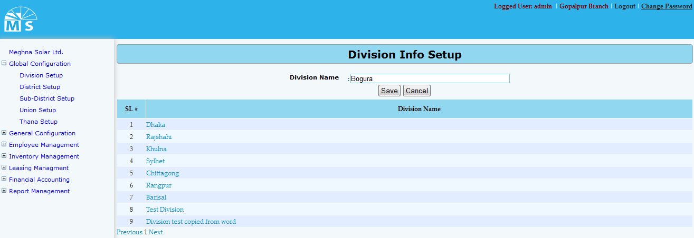

**Division Info Setup**

**Here user needs to enter Division Name in the text box and click Save Button to save the Division. Recently saved Divisions will be visible in the below grid view. For updating any Division user need to click on the Division name in the grid view. Then after modifying the division info in the text box like the below picture, user need to Press Update button. After this, modified division name can be seen in the grid view. User can also delete the Division name here.**

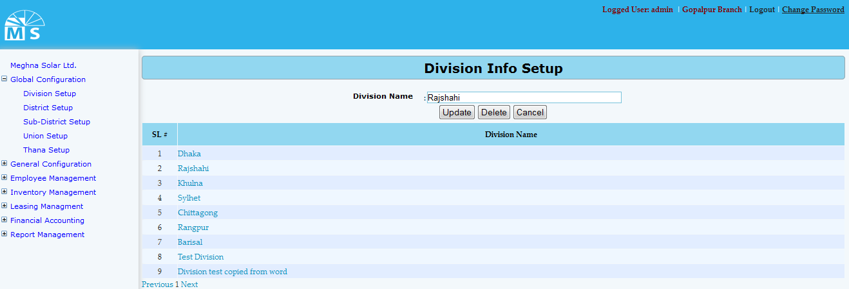

**Division Info Update**

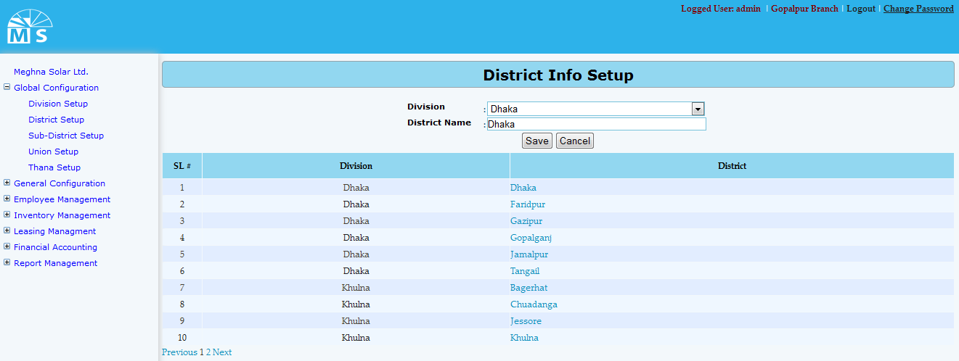

**District Info Setup**

**Here user needs to select Division name from the division dropdown list. Then enter District Name under that Dvision in the text box and click Save Button to save the District. Recently saved District will be visible in the below grid view. For updating any District user need to click on the District name in the grid view. Then after modifying the Division and District info in the text box, user need to Press Update button. After this, modified District name can be seen in the grid view.**

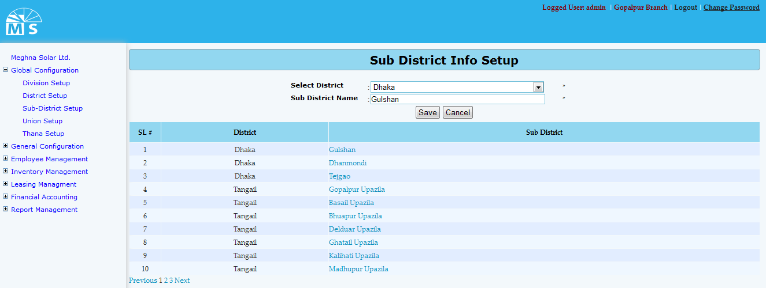

**Sub District Info Setup**

**Here user needs to select District name from the District dropdown list. Then enter Sub District Name under that District in the text box and click Save Button to save the Sub District. Recently saved Sub District will be visible in the below grid view. For updating any Sub District user need to click on the Sub District name in the grid view. Then after modifying the District and Sub District info in the text box, user need to Press Update button. After this, modified Sub District name can be seen in the grid view.**

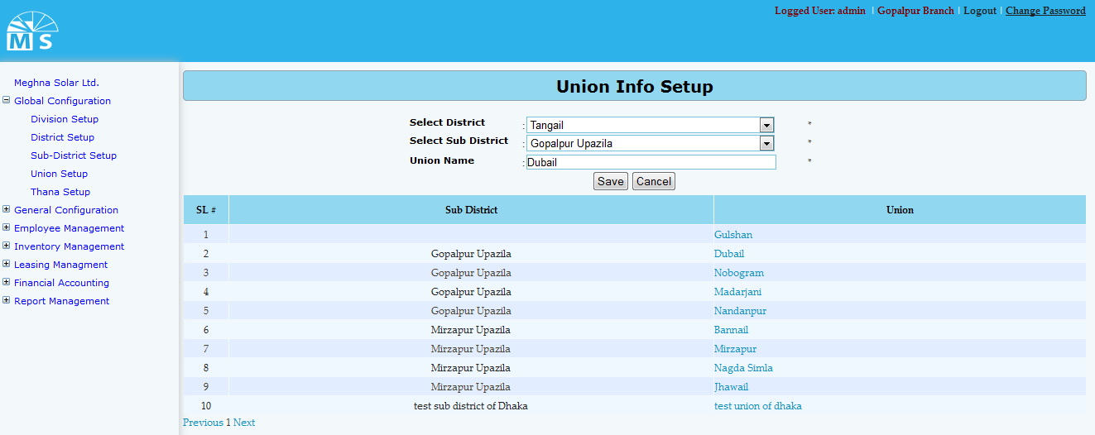

**Union Info Setup**

**Here user needs to select District name and Sub District name from the following dropdown list. Then enter Union Name under that District and Sub District in the text box and click Save Button to save the Union. Recently saved Union will be visible in the below grid view. For updating any Sub District user need to click on the Union name in the grid view. Then after modifying the District, Sub District and Union info in the text box, user need to Press Update button. After this, modified Union information can be seen in the grid view.**

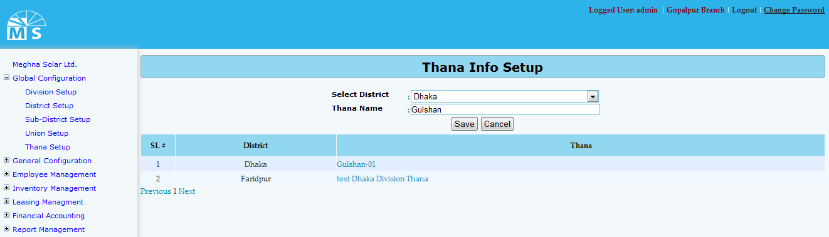

**Thana Info Setup**

**Here user needs to select District name from the following dropdown list. Then enter Thana Name under that District in the text box and click Save Button to save the Thana. Recently saved Thana will be visible in the below grid view. For updating any Thana user need to click on the Thana name in the grid view. Then after modifying the District and Thana info in the text box, user need to Press Update button. After this, modified Thana information can be seen in the grid view.**

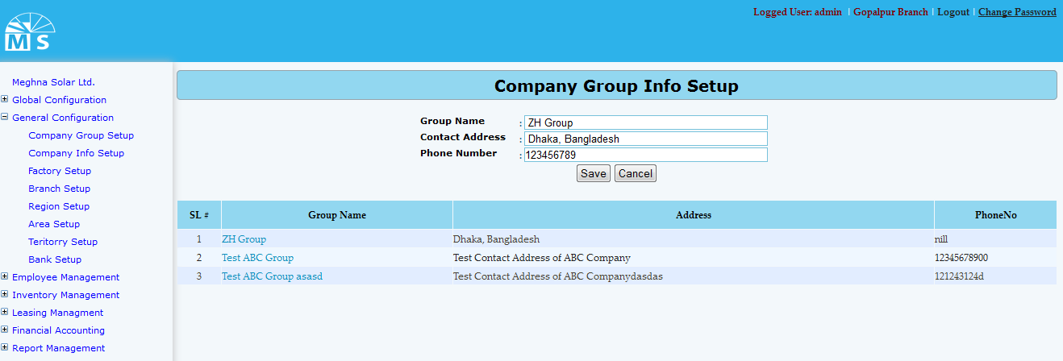

**Company Group Info Setup**

**Here, user needs to enter Group Name, Contact Address and Phone No. of the company in the text box and click Save Button to save Company group information. Recently saved Company group information will be visible in the below grid view. For updating any information user need to click on the Group name in the grid view. Then after modifying the division info in the Upper text box like the picture below, user need to Press Update button. After this, modified Company group information will be seen in the grid view. In this process user can also delete data.**

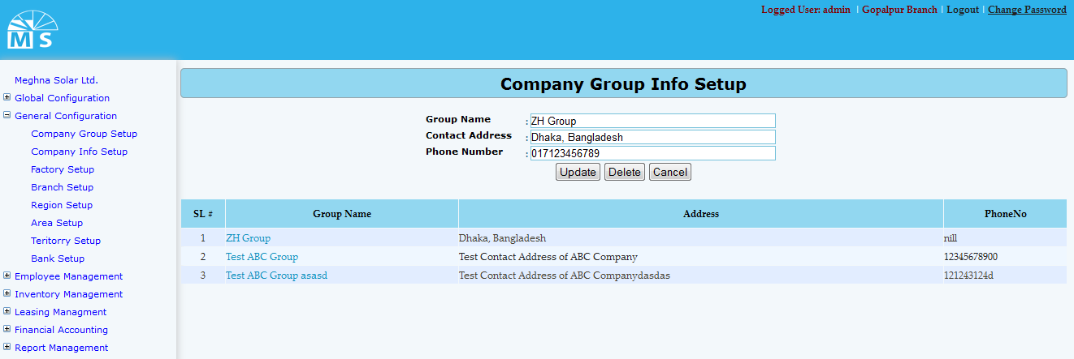

**Company Group Info Update**

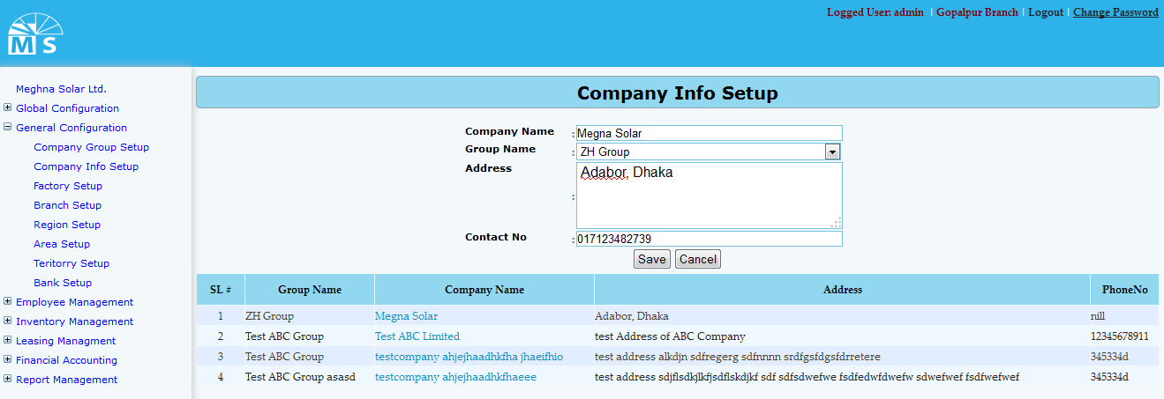

**Company Info Setup**

**Here user needs to enter Company name and select Group name from the dropdown list. Then enter Company address and contact no. in the text box and click Save Button to save Company Information. Recently saved Information will be visible in the below grid view. For updating any Company information user need to click on the Company name in the grid view. Then after modifying the information, user need to Press Update button. After this, modified Company information can be seen in the grid view.**

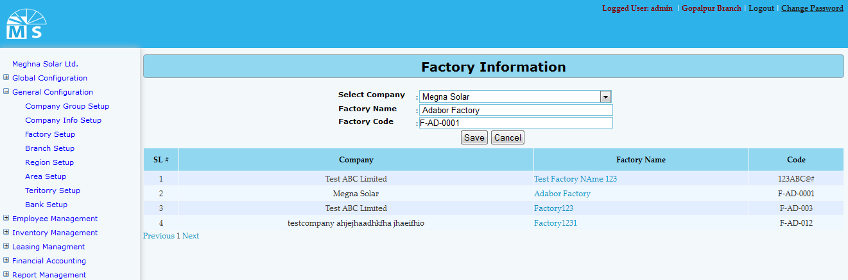

**Factory Info Setup**

**Here user needs to select Company name from the dropdown list. Then enter Factory Name and Factory Code in the text box and click Save Button to save Factory Information. Recently saved Factory Information will be visible in the below grid view. For updating any Factory Information user need to click on the Factory name in the grid view. Then after modifying the Factory Information user need to Press Update button. After that, modified Factory Information can be seen in the grid view.**

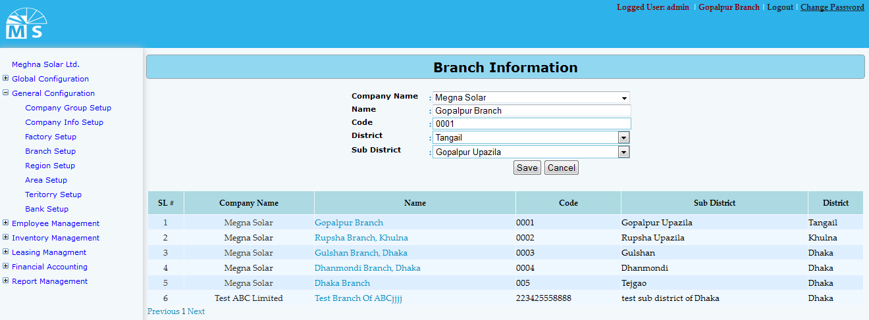

**Branch Info Setup**

**Here user needs to select Company name, District name and Sub District name from the following dropdown list. Then enter Branch name and Code in the text box and click Save Button to save the Branch. Recently saved Branch will be visible in the below grid view. For updating any Branch Information user need to click on the Branch name in the grid view. Then after modifying the Branch information, user need to Press Update button. After that, modified Branch information can be seen in the grid view.**

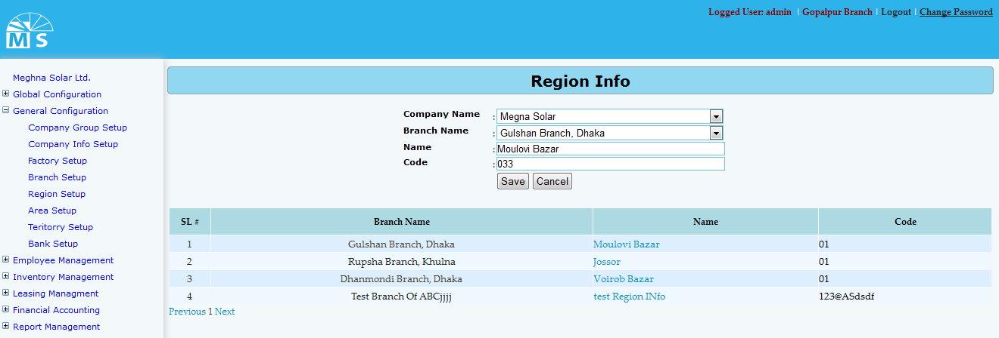

**Region Info Setup**

**Here user needs to select Company name and Branch name from the following dropdown list. Then enter Region name and code in the text box and click Save Button to save the Region. Recently saved Region will be visible in the below grid view. For updating any Region user need to click on the Region name in the grid view. Then after modifying the Region info in the text box, user need to Press Update button. After this, modified Region information can be seen in the grid view.**

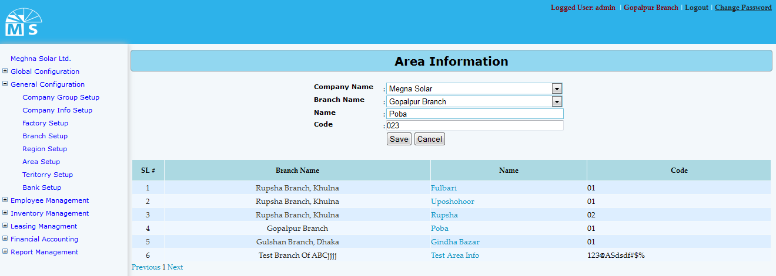

**Area info Setup**

**Here user needs to select Company name and Branch name from the following dropdown list. Then enter Area name and code in the text box and click Save Button to save the Area. Recently saved Area will be visible in the below grid view. For updating any Area user need to click on the Area name in the grid view. Then after modifying the Area info in the text box, user need to Press Update button. After that, modified Area information can be seen in the grid view.**

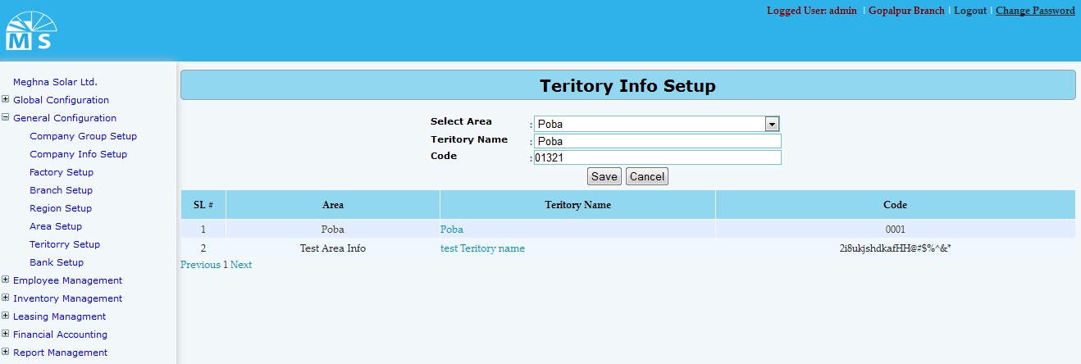

**Teritory Info Setup**

**Here user needs to select Company name and Branch name from the following dropdown list. Then enter Area name and code in the text box and click Save Button to save the Area. Recently saved Area will be visible in the below grid view. For updating any Area user need to click on the Area name in the grid view. Then after modifying the Area info in the text box, user need to Press Update button. After that, modified Area information can be seen in the grid view.**

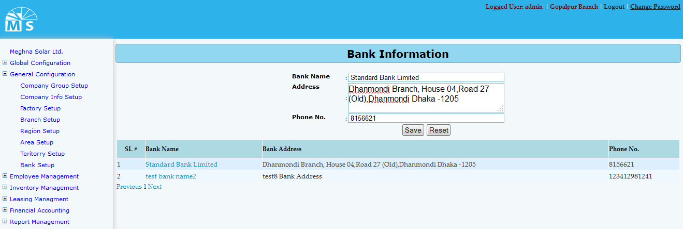

**Bank Info Setup**

**Here user needs to enter Bank name, Bank address and Phone No. in the text box and click Save Button to save the Bank. Recently saved Bank will be visible in the below grid view. For updating any Bank user need to click on the Bank name in the grid view. Then after modifying the Bank info in the text box, user need to Press Update button. After that, modified Bank information can be seen in the grid view**

**Employee Management**

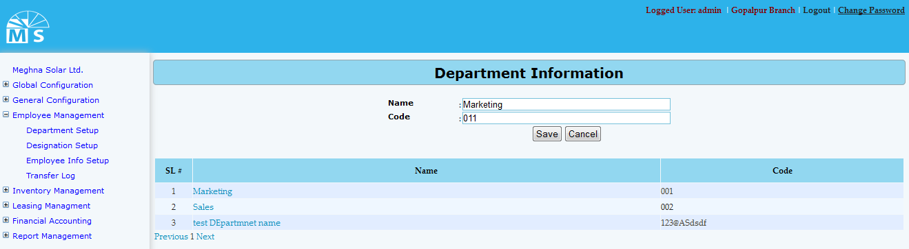

**Department Info Setup**

**Here user needs to enter Department name and Code in the text box and click Save Button to save Department information. Recently saved Department information will be visible in the below grid view. For updating any information user need to click on the Department name in the grid view. Then after modifying the Department info in the Upper text box, user need to Press Update button. After that, modified Department information will be available in the grid view.**

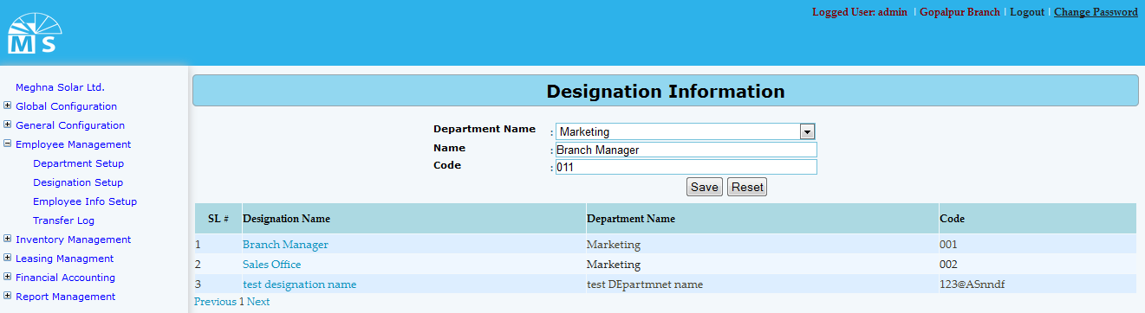

**Designation Info Setup**

**Here user needs to select Department name from the dropdown list. Then enter Designation name and code in the text box and click Save Button to save Designation Information. Recently saved Information will be visible in the below grid view. For updating any Designation information user need to click on the Designation name in the grid view. Then after modifying the information, user need to Press Update button. After that, modified Designation information can be seen in the grid view.**

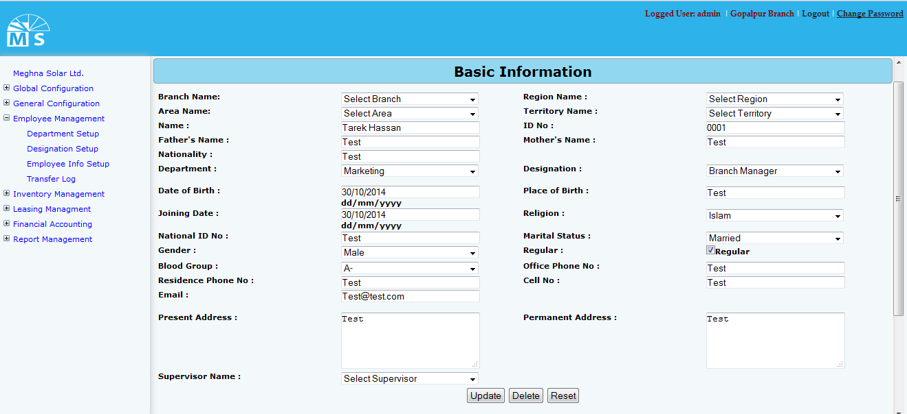

**Employee Info Setup(Basic Information)**

**Here user needs to enter Employ’s basic information. For that top of the entry form user need to select Branch, Region, Area and Territory name from the dropdown list. Then user need to entry employ’s name, ID no., Employ’s Father’s name, mother’s name and nationality in the text box . After that user need to select department name and Designation from drop down list and enter Date of birth, place of birth and Joining Date. Then after selecting religion,Maritial Status, gender and blood group from drop down list user need to enter National Id no., employ’s contact no., email address, present and permanent address in the text box.At last User need to select a Supervisor of that emplyee from Supervisor name drop down list .**

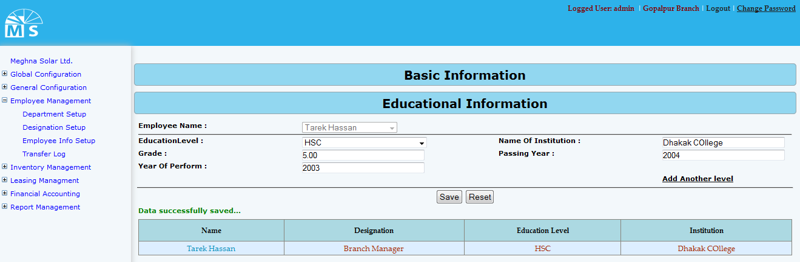

**Employee Info Setup(Educational Information)**

**For entering educational information of an emplloyee user need to select employee from Employee dropdown list. Then for each education level user need to selelct from drop down list (ex: JSC, SSC, HSC, Masters etc.). User also need to enter Institution name, Grade,Passing Year and year of Perform in the following text field.**

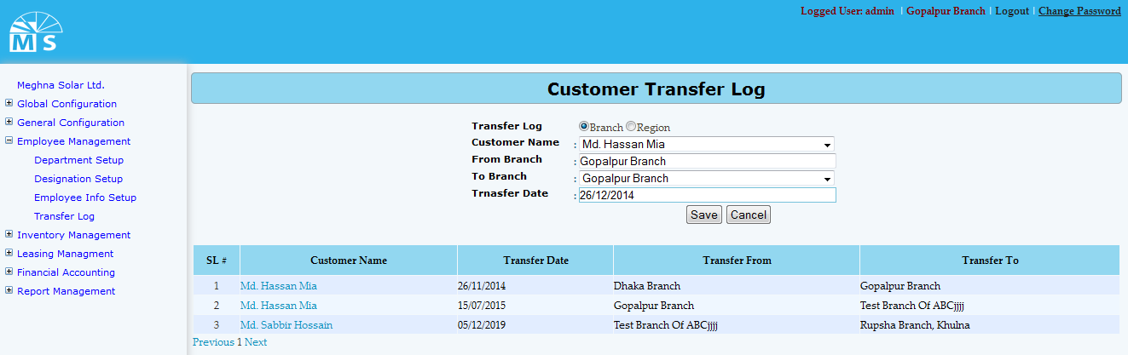

**Customer Transfer Log (Branch wise)**

**Here user first needs to decide whether to insert data Branch wise or Region wise. According to that, branch and region should be sellected from the top radio button sellection. Then user need to select Customer name from the dropdown list. After that user need to enter From and to branch and transfer Date in the text boc and click Save Button to save transfer log. Recently saved Transfer Log will be visible in the below grid view. For updating user need to click on the Customer name in the grid view. Then after modifying the info in the text box, user need to Press Update button. After that, modified Transfer Log information can be seen in the grid view.**

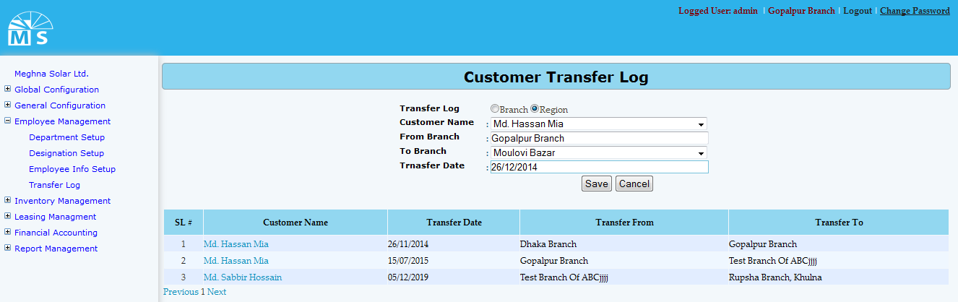

**Customer Transfer Log (Region wise)**

**Here user needs to select Region from the second drop down list, enter other information and click Save Button to save Customer Transfer Log. Recently saved information will be visible in the grid view. For updating any informartion user need to click on customer name in the grid , modify info in text box and click update button to see modified info in the grid view.**

**Inventory Managmnet**

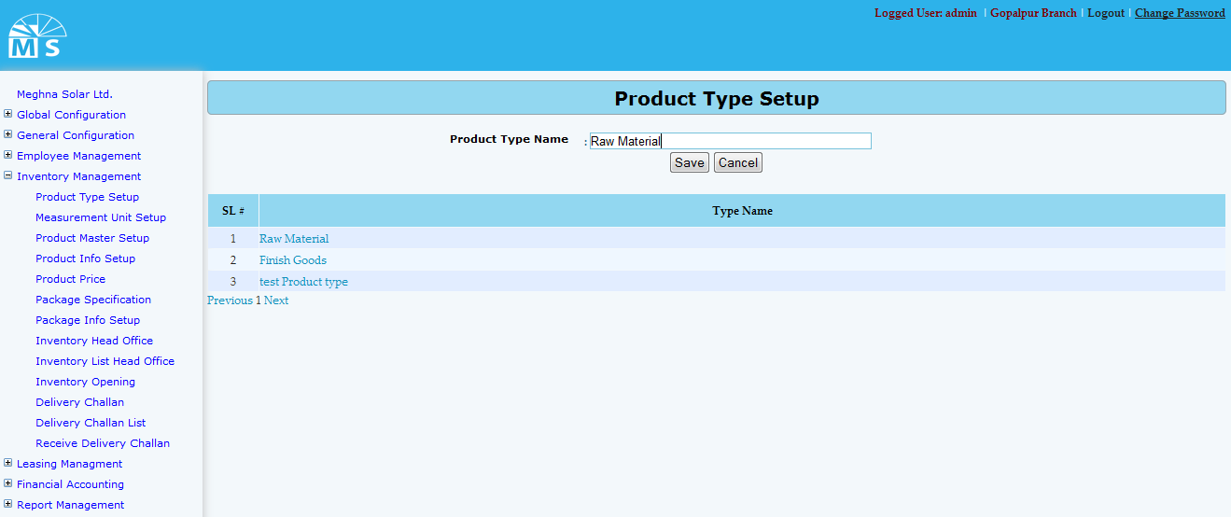

**Product type Setup**

**Here user needs to enter Product type name in the text box and click Save Button to save Product type name information. Recently saved Product type information will be visible in the below grid view. For updating any information user need to click on Type name in the grid view. After modifying the name, user need to Press Update button. After that, modified Product type information will be available in the grid view.**

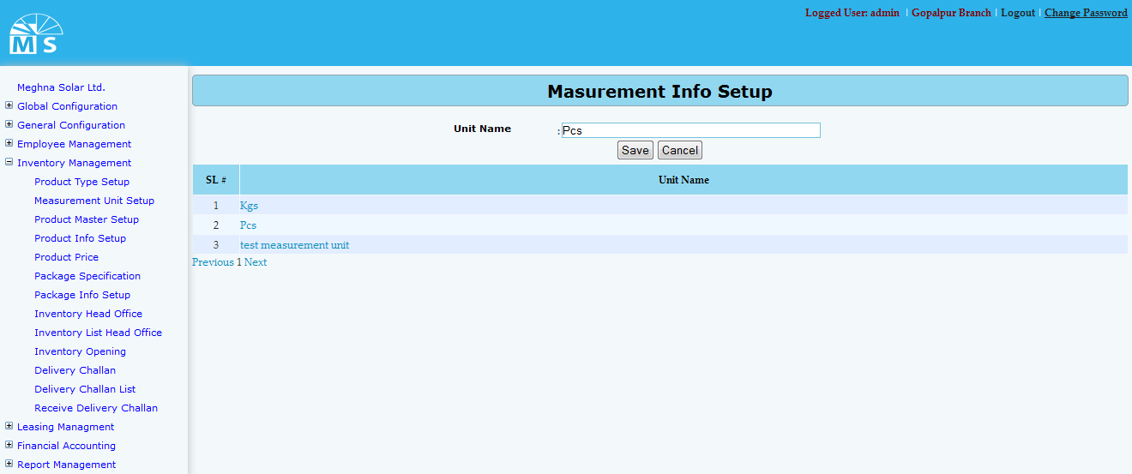

**Measurement unit Setup**

**Here user needs to enter Measurement unit name in the text box and click Save Button to save Measurement unit name information. Recently saved Measurement unit information will be visible in the below grid view. For updating any information user need to click on unit name in the grid view. After modifying the name, user need to Press Update button. Then, modified Measurement unit information will be available in the grid view.**

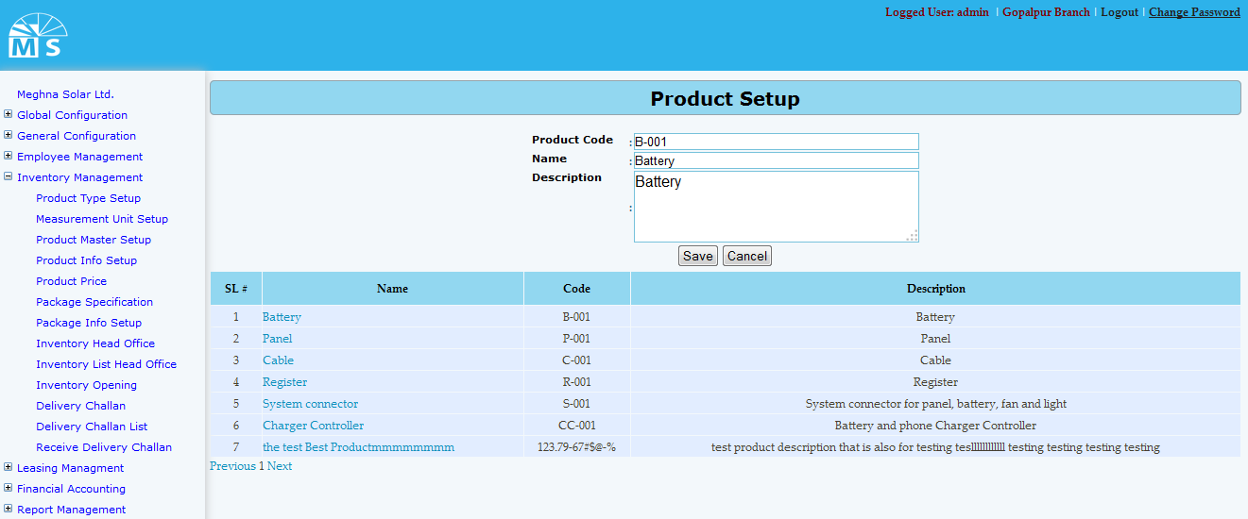

**Product master setup**

**Here user needs to enter Product Code, Product name and Product description in the text field. Then user need to click Save Button to save Product master setup information. Recently saved information will be visible in the grid view. For updating any informartion user need to click on Product name in the grid , modify info in text box and click update button to see modified info in the grid view.**

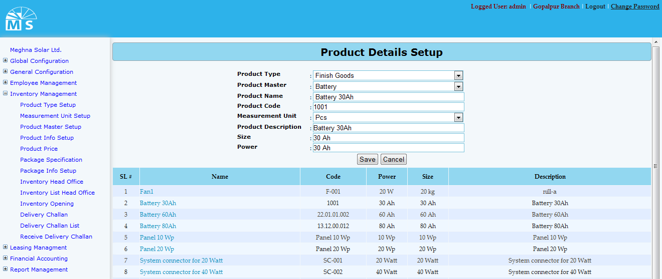

**Product Details setup**

**Here user needs to select Product Type and Product Master form the top two drop down list. Then user need to enter Product Code, Product name . After that selecting measurement unit from dropdown list user also neeed to enter product description, Size and Power in the text field. Then user need to click Save Button to save Product details information. Recently saved information will be visible in the grid view. For updating any informartion user need to click on Product name in the grid , modify info in text box and click update button to see modified info in the grid view.**

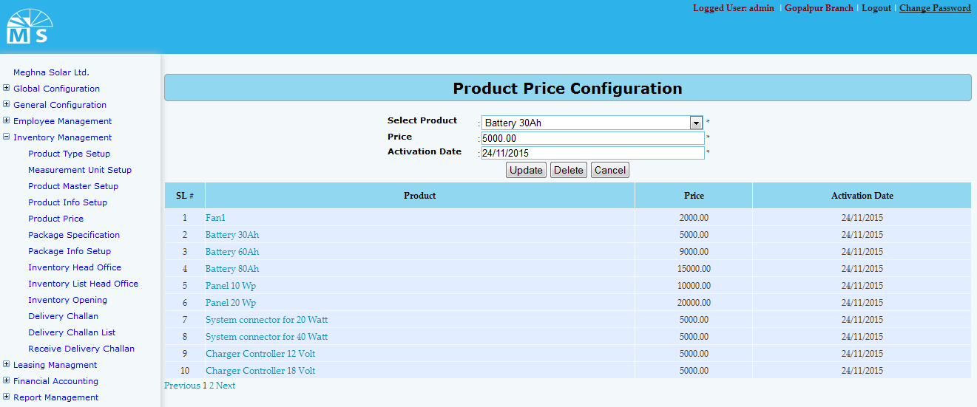

**Product Price Configuration setup**

**Here user needs to select Product form the top drop down list. Then enter Product price and Activation date. Then for new product user need to click Save Button and for existing price user need to click update button to save Price information. Recently saved/Updated information will be visible in the grid view. User also can delelte**

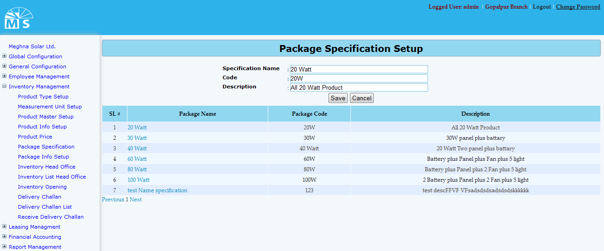

**Package Specification setup**

**Here user needs to enter Specification name, code and description in the text box. Then user need to click Save Button to save Package Specification information. Recently saved information will be visible in the grid view. For updating any informartion user need to click on Package name in the grid , modify info in text box and click update button to see modified info in the grid view.**

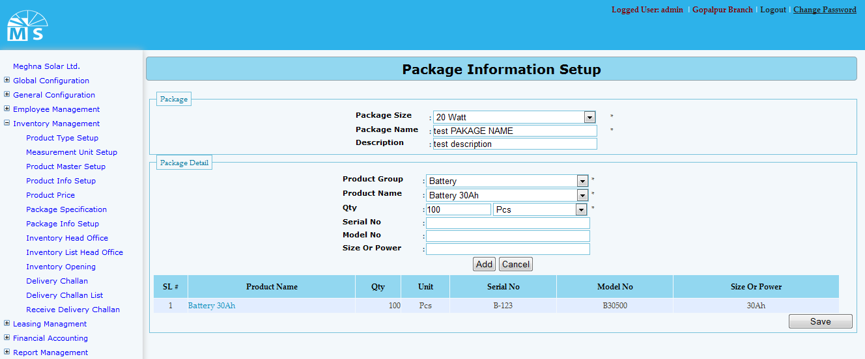

**Package Information setup**

**Here in package section user needs to select package size from the drop down list and enter Package name and Description. Then in Package Detail user need to selelct product group, product name,Quantity,Measurement Unit from drop down list. Then he need to enter serial no,model no and size or power value in texbox. If user click Add button then the pakage detail will be visible in the gridview. Like this user can add more than one details. At last user need to click Save button to save the Package information.**

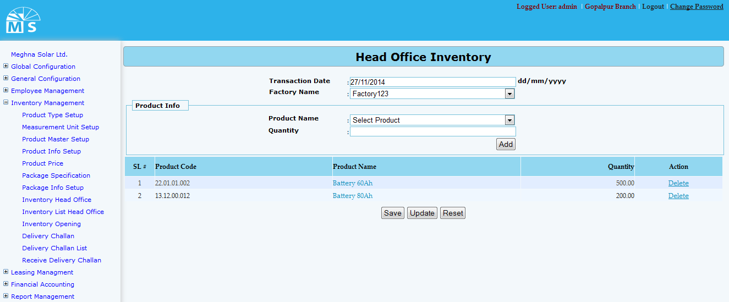

**Head Office Inventory**

**Here in Head Office Inventory user need to enter transaction date and select factory name from drop down list. Then in Product Info section User need to select product name from drop down list and enter quantity value to add product in the gridview. Besides adding product User can also delete product from gridview. Then at last User need to press save button for new entry and update button for modifying existing information.At last user need to save the whole Inventory information by clicking Save button.**

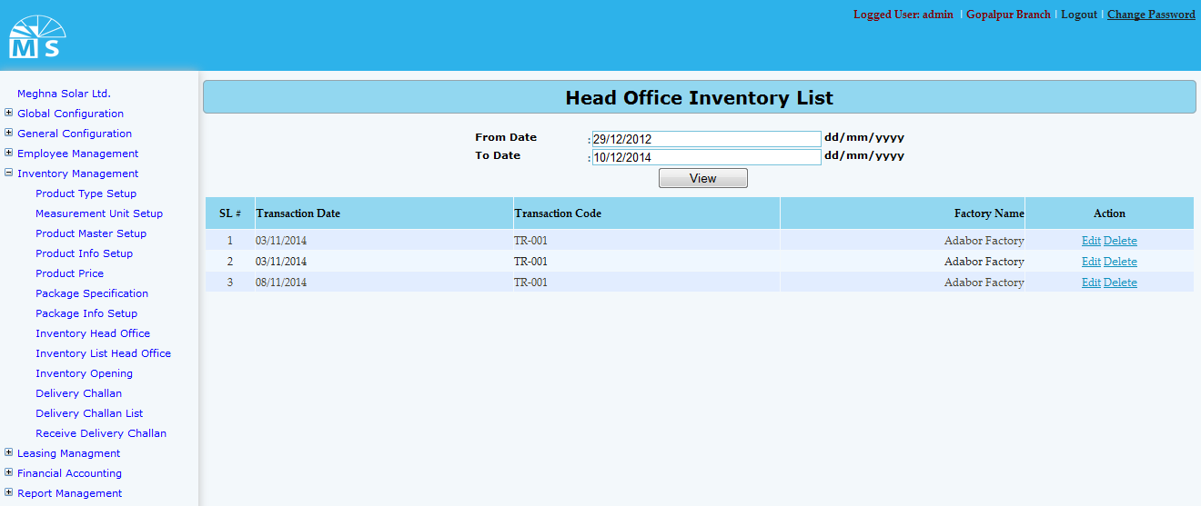

**Head Office Inventory List**

**Here in Head Office Inventory List user can search/view inventory list by inserting from date and to date. After clicking view button inventory list between the dates will be shown in the grid. From there user can edit or delete inventory details.**

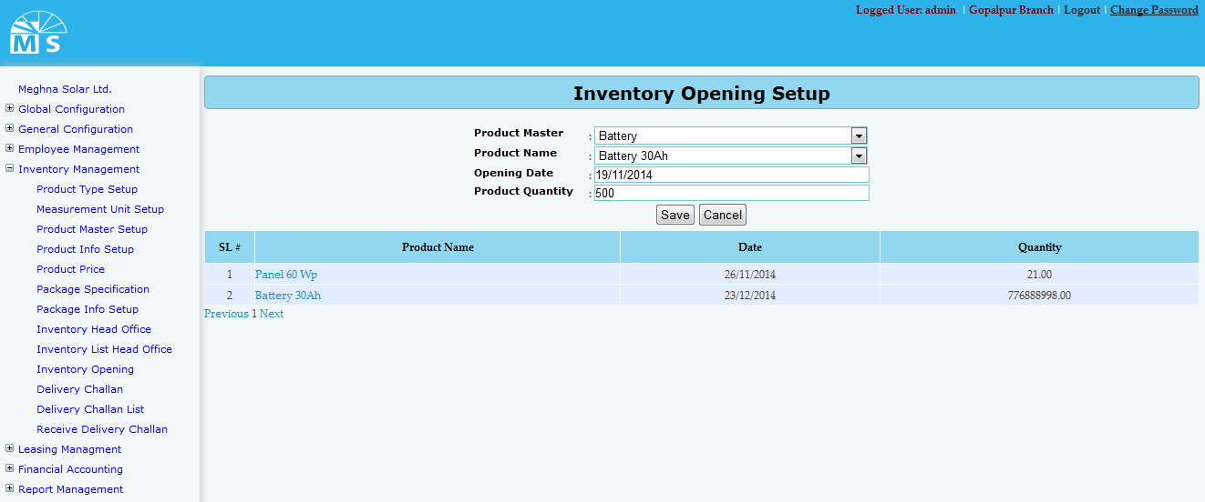

**Inventory Opening Setup**

**Here in Inventory Opening Setup user need to enter Product master and product name from drop down list. Then need to enter opening date and product quantiy to save Inventory Opening Setup information. After clicking save button information will be visible in the gridview. For updating user need to click on product name to update any information.**

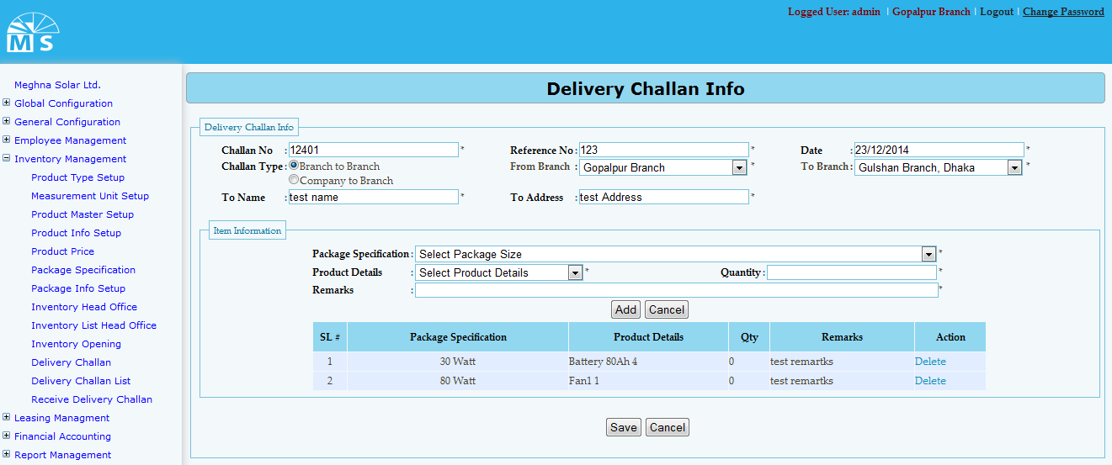

**Delivery Challan Info**

**Here in Delivery Challan Info there is two section. At first in delivery challan info section user need to enter challan no, referrence no,challan type, date, branch, to name and challan address. Then in Item info section user need to sellect package specification and package detail from drop down list. Then user need to enter quantity and remarks to add item info in grid. User can add more than one item info. At last user need to click save button to save delivery challan info.**

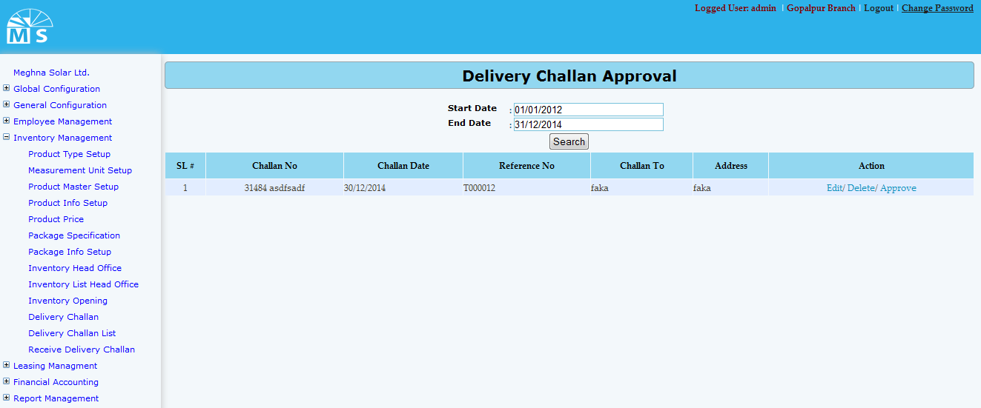

**Delivery Challan Approval**

**Here in Delivery Challan Approval user can search delivery challn info date wise. After providing Start and end date user need to click search button. Then the delivery challn info become visible in the grid view.From there user can Edit, dellete or appve the delivery challan info**

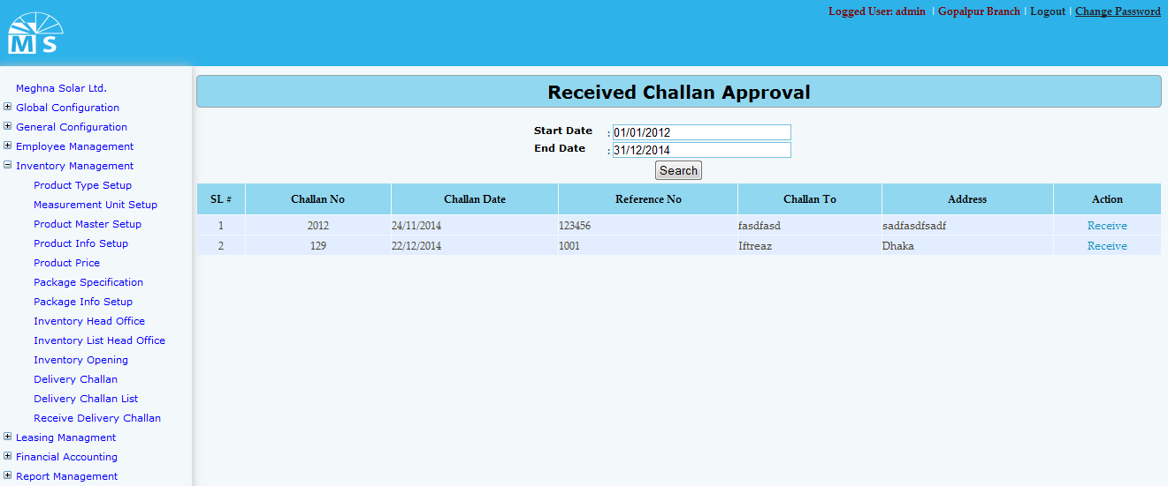

**Received Challan Approval**

**Here in Received Challan Approval user can search receive challn date wise and also can approve them as well. For that user need to enter start and end date and click search button. Then received challn between the date range will be visible in the grid. Fron there user can receive Challan.**

**Financail Accounting**

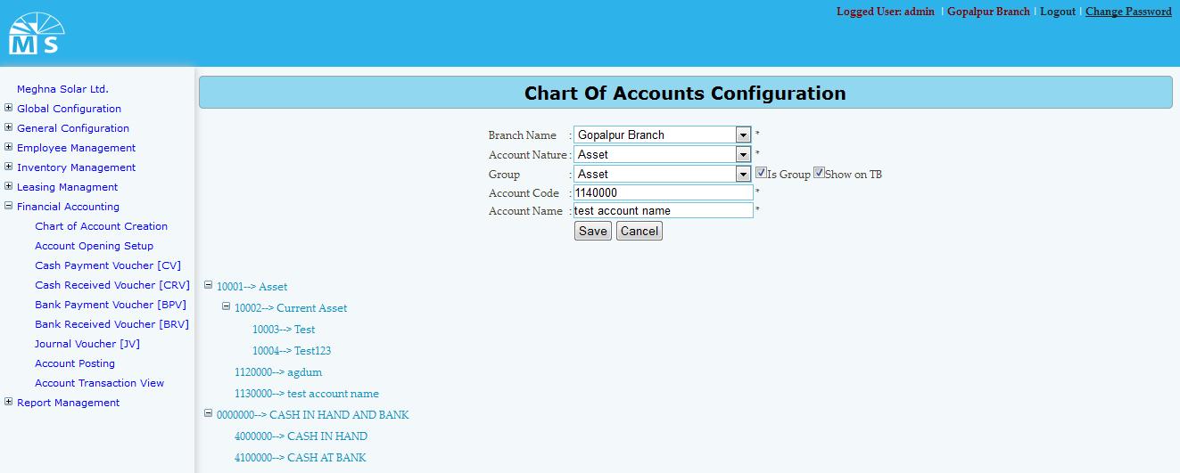

**Chart of Accounts Configuration**

**Here user needs to select branch name, Account nature, and group from drop down list. Then user also needs to enter account code and account name to save chart of accounts configuration. Saved chart of accounts configuration will be visible below in tree diagram. If modification needed, user can click on the tree branch to modify information.**

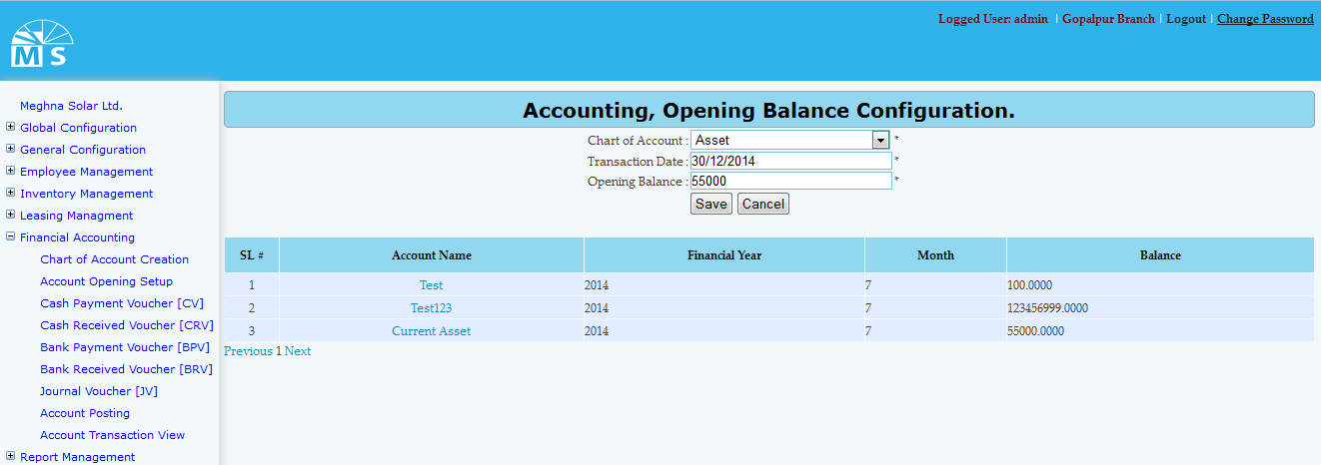

**Account opening Setup**

**Here user needs to select chart of account from the drop down list then need to enter transaction date and opening balance to save opening balance info. After clicking save button information will be visible in the grid view. For any modification user need to click on account name in the grid view. After modifying information, user need to Press Update button. Then, modified information will be available in the grid view.**

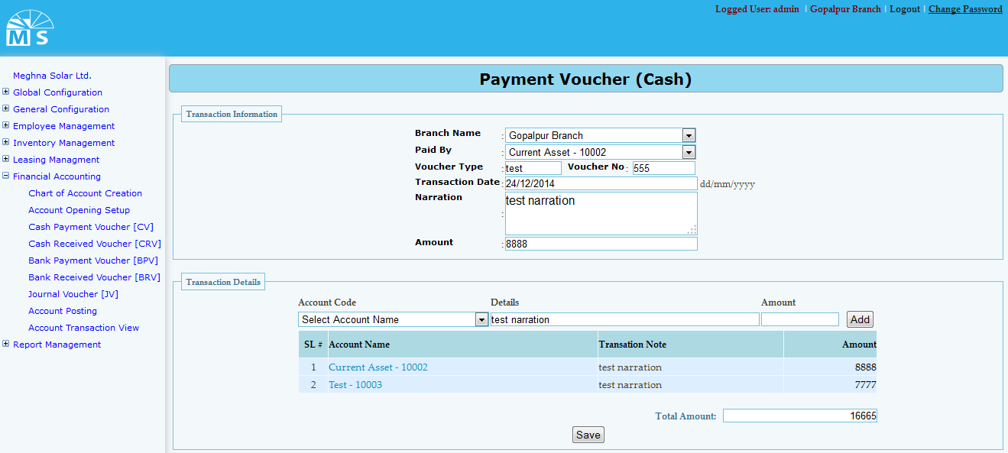

**Payment Voucher (CV)**

**Here in Payment Voucher cash, there are two section. At first in transaction information section user needs to select branch name and paid by from drop down list. Then user also need to enter Voucher type, voucher no, transaction date, narration and ammount. Then in Second section named Transaction detail user need to add transaction detail information. For that user need to selelct accounr code from drop down and enter details and amount to add info. Added info will be visible in grid. Below Total amounrt will be shown. Then user need to click Save Button to save Payment Voucher (CV) information.**

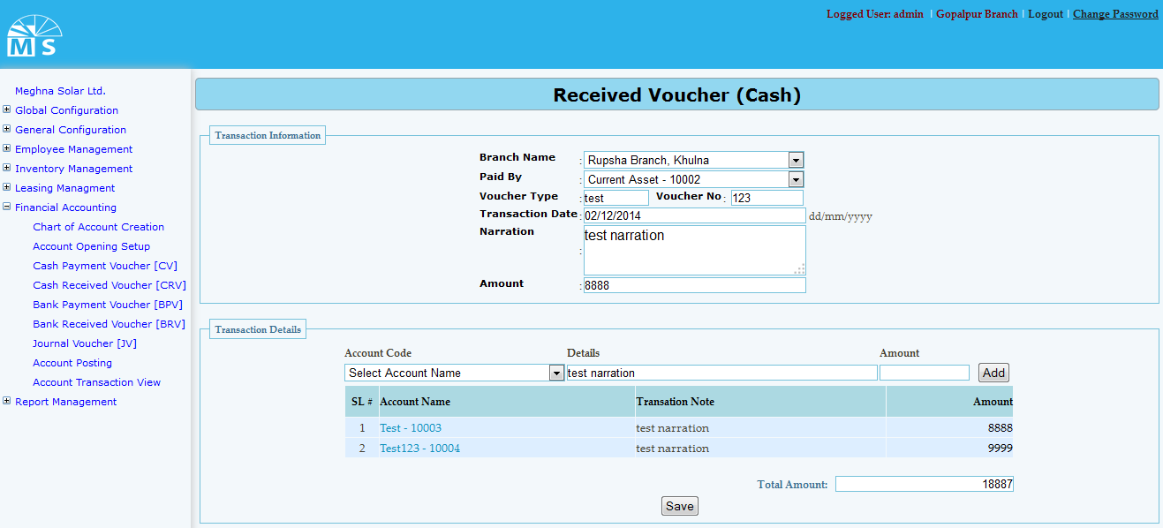

**Cash Receive Voucher**

**Here in Cash receive voucher user needs to select branch name and paid by from drop down list. Then user also need to enter Voucher type, voucher no, transaction date, narration and ammount in first section. Then in Second section named Transaction detail user need to add transaction detail information. For that user need to selelct accounr code from drop down and enter details and amount to add info. Added info will be visible in grid. Below Total amounrt will be shown. Then user need to click Save Button to save Cash Receive Voucher information.**

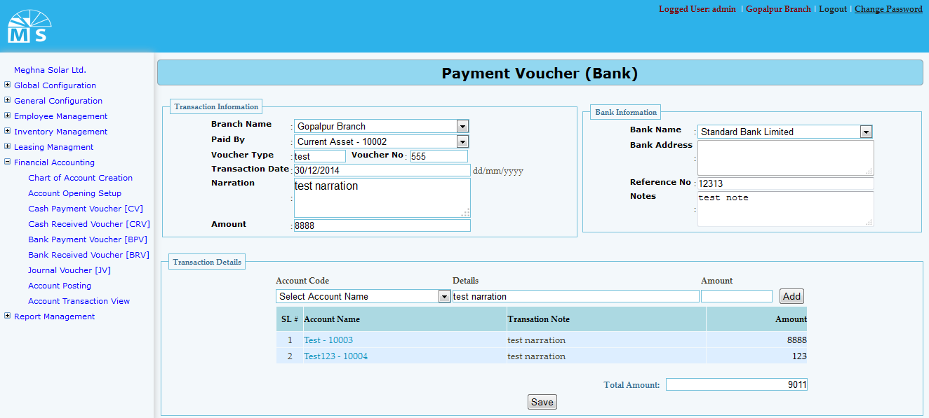

**Bank Payment Voucher**

**Here we have three section Traction information, Bank information and transaction details. User user needs to select branch name and paid by from drop down list. Then user also need to enter Voucher type, voucher no, transaction date, narration and amount in first section. In second section user need to enter Bank information like Bank name, address, referrence no and note details.Then in Third section named Transaction detail user need to add transaction detail information. For that user need to selelct accounr code from drop down and enter details and amount to add info. Added info will be visible in grid. Below Total amounrt will be shown. Then user need to click Save Button to save Bank Receive Voucher information.**

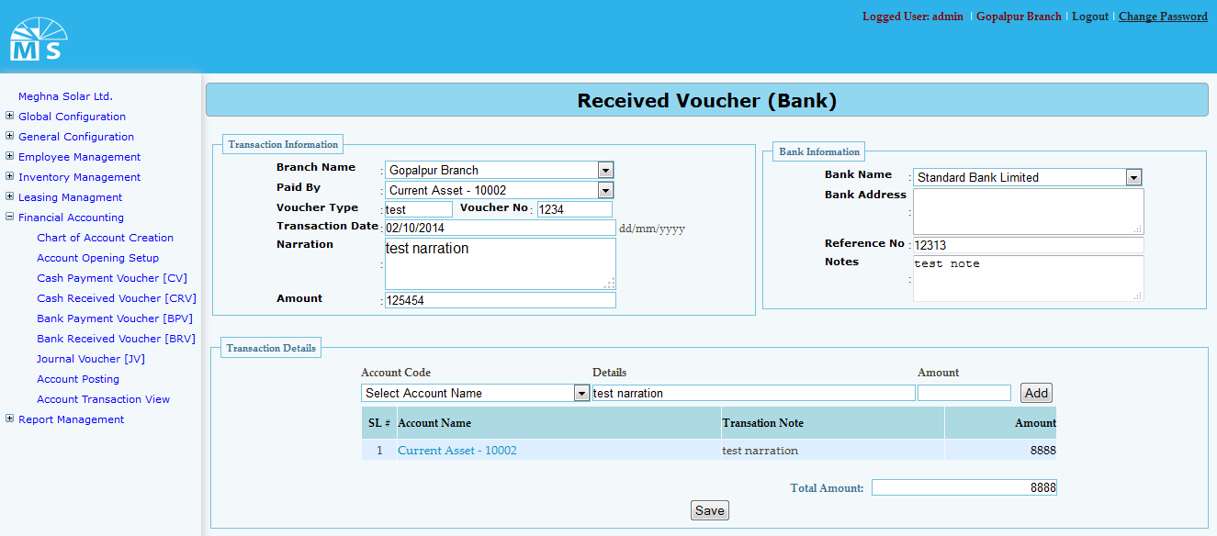

**Bank Receive Voucher**

**Here we also have three sections. User user needs to select branch name and paid by from drop down list. Then user also need to enter Voucher type, voucher no, transaction date, narration and amount in first section. In second section user need to enter Bank information like Bank name, address, referrence no and note details.Then in Third section named Transaction detail user need selelct accounr code from drop down and enter details and amount to add info. Added info will be visible in grid. Below Total amounrt will be shown. Then user need to click Save Button to save Bank Receive Voucher information.**

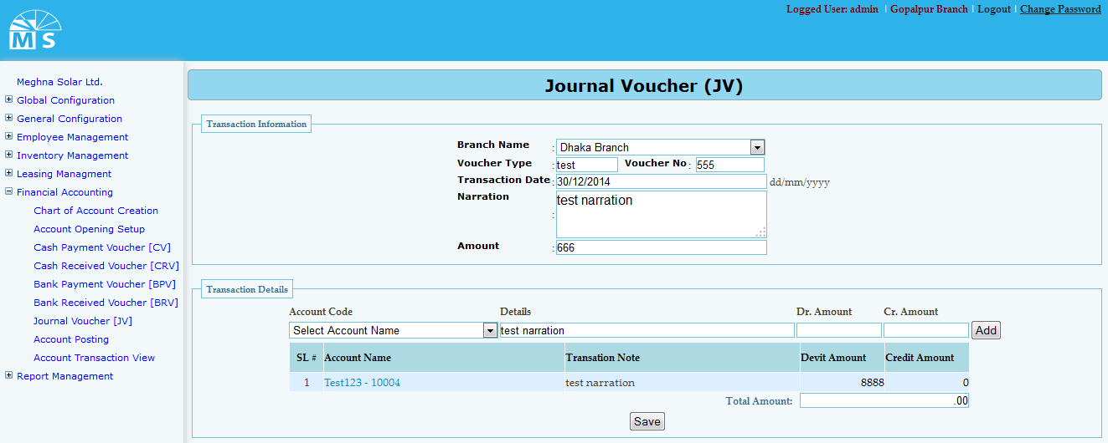

**Journal Voucher**

**Here in Journal voucher user needs to select branch name from drop down list. Then user also need to enter Voucher type, voucher no, transaction date, narration and ammount in first section. Then in Second section named Transaction detail user need to add transaction detail information. For that user need to selelct accounr code from drop down list, enter details and amount to add info. Added info will be visible in grid. Below Total amounrt will be shown. Then user need to click Save Button to save Journal Voucher information.**

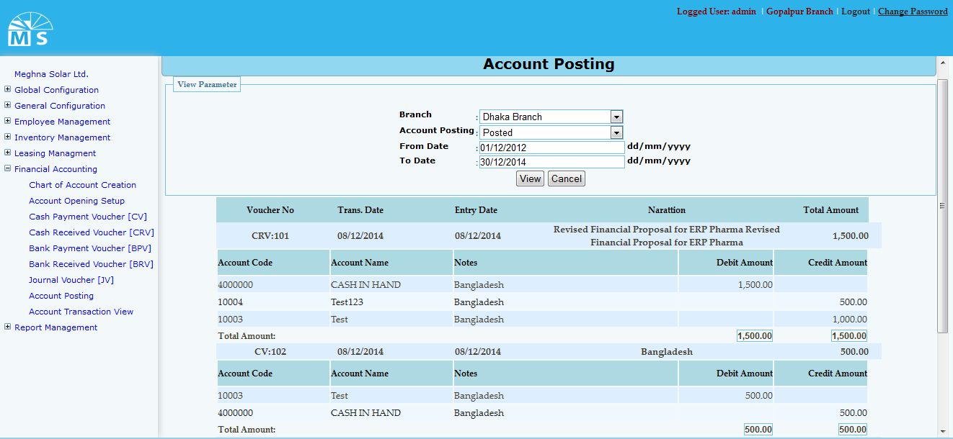

**Account Posting**

**Here in Account Posting section user need to select branch and account posting from drop down list.Then user need to enter date range and click view button. After that account information will be visible in the grid view below.**

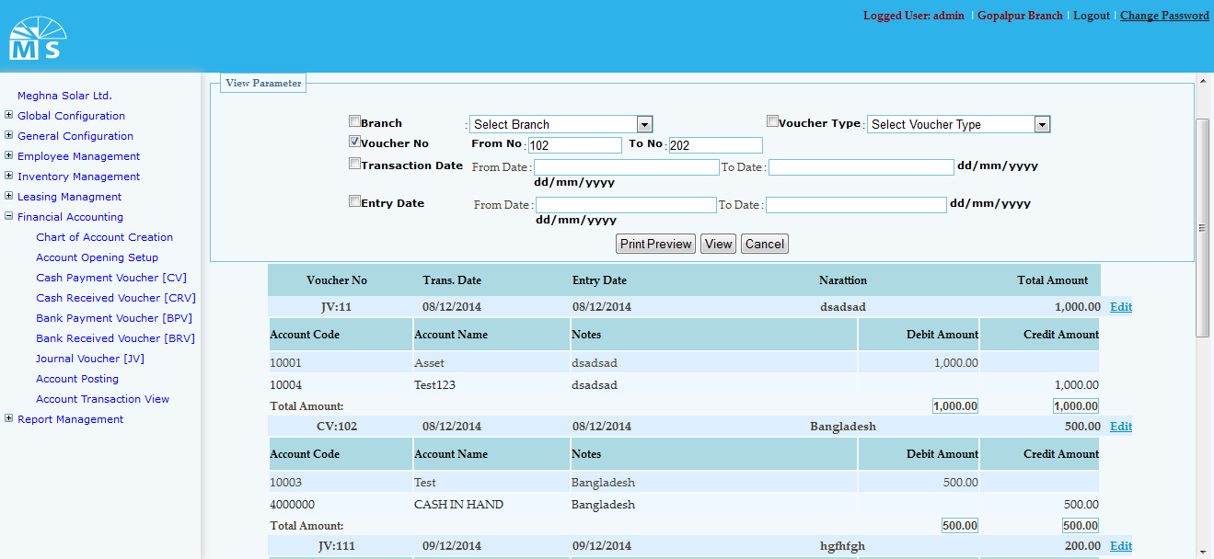

**Account transaction view**

**Here in Account transaction view user can print, view voucher information by selecting different cryteria in view parameter section. The parameters are branch name, voucher type, voucher no, transaction date and entry date.**

**Leasing Installment Management**

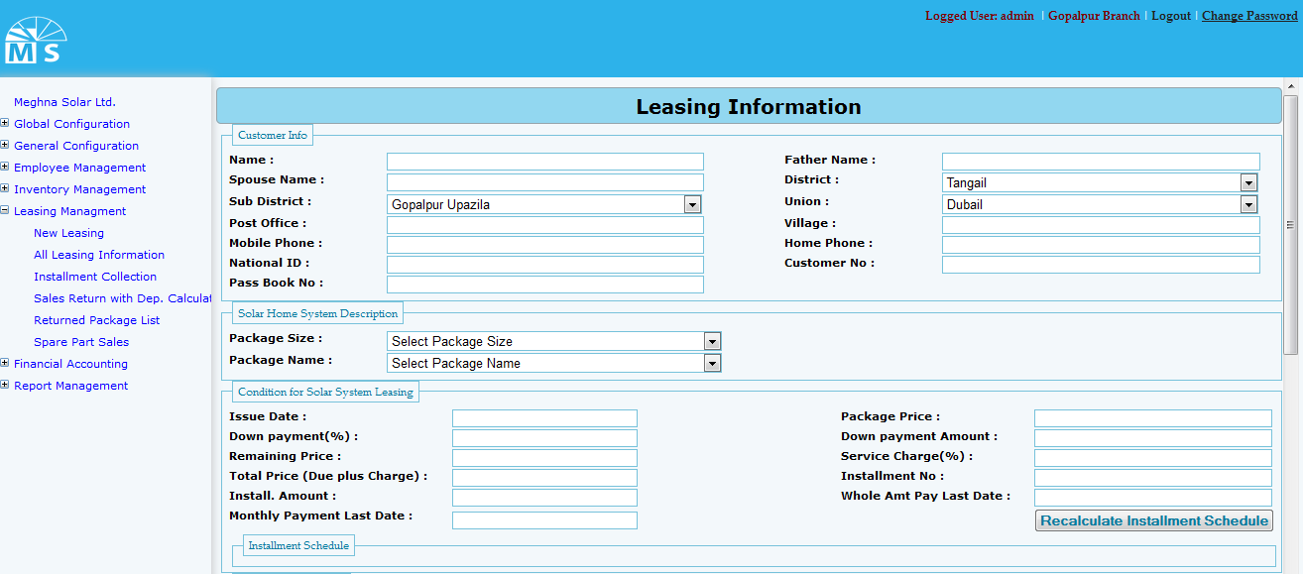

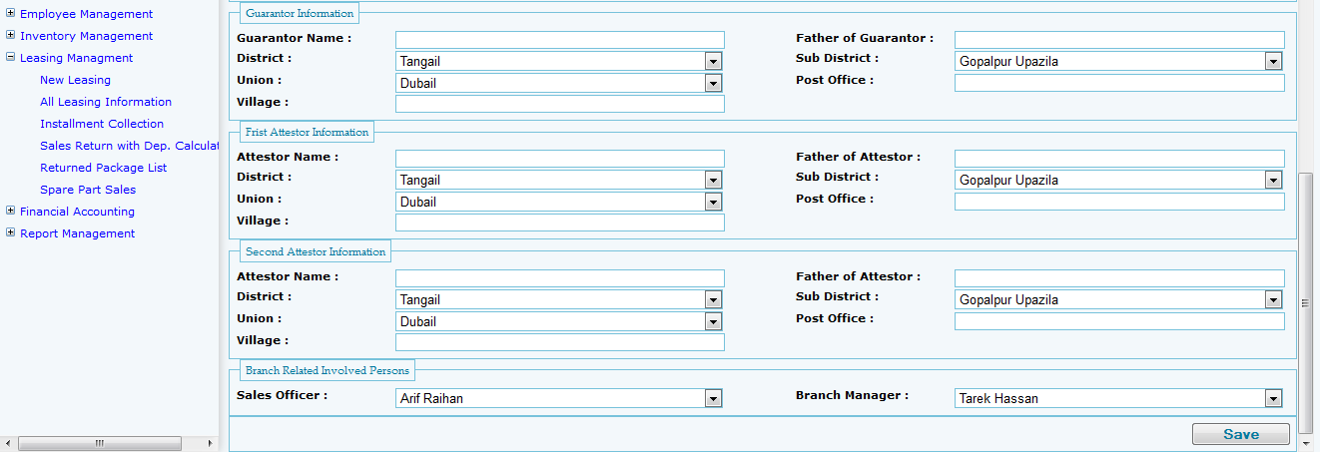

**New Leasing Information entry page**

**Here in Leasing Information user needs to enter information related to leasing. They are Customer Info, Solar home system information, Condition of solar system leasing, installment info, guarantor info, first attester and second attester information. After providing all required information stated above user need to press save button to save all the information in the entry form. After saving the information user will get success message for successfully completion of task and error message for any error or blank field in the form.**

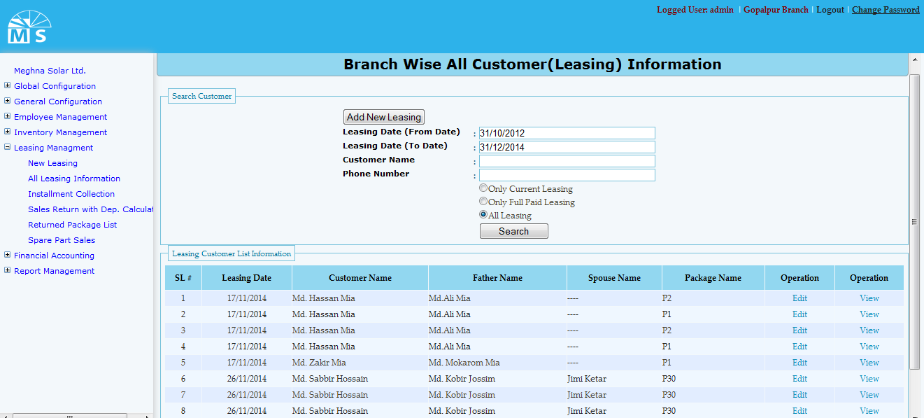

**All Leasing Information**

**Here in All Leasing information user can search leasing information by providing leasing date range. like the upper picture user can search only providing date range. But for specific person user need to provide customer name and his phone no. There are three category for search. They are: only current leasing, only full paid leasing and last one is all leasing. After the search button clicked if data exist among the date range that will be shown in the grid view below. User can View and edit info from the grid view.**

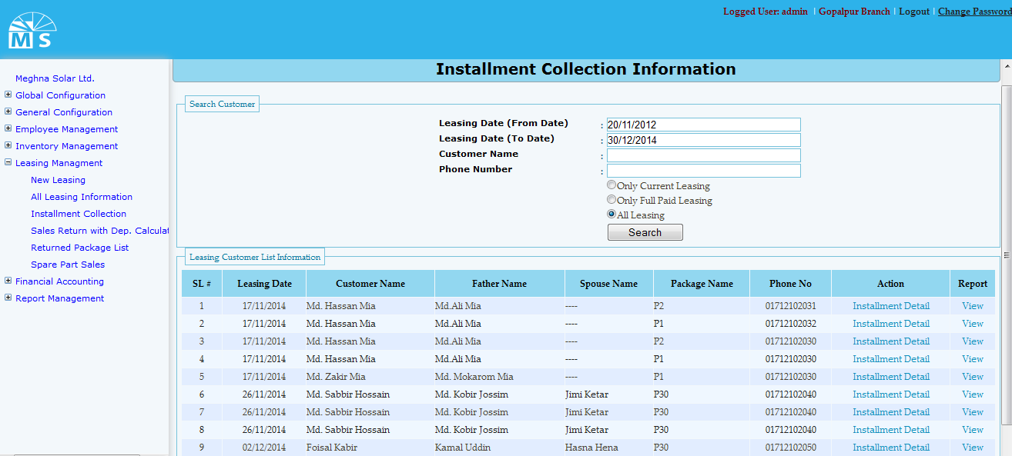

**Factory Info Setup**

**In Factory info setup user needs to entry leasing date range (from date and to date) for searching installment collection information. User can search in three category. They are Only current, full paid and All leasing. For specific Custermer report user need to give input of customer name and Phone no of the customer before clicking search button.User can view install ment detail from the information in Gridview.**

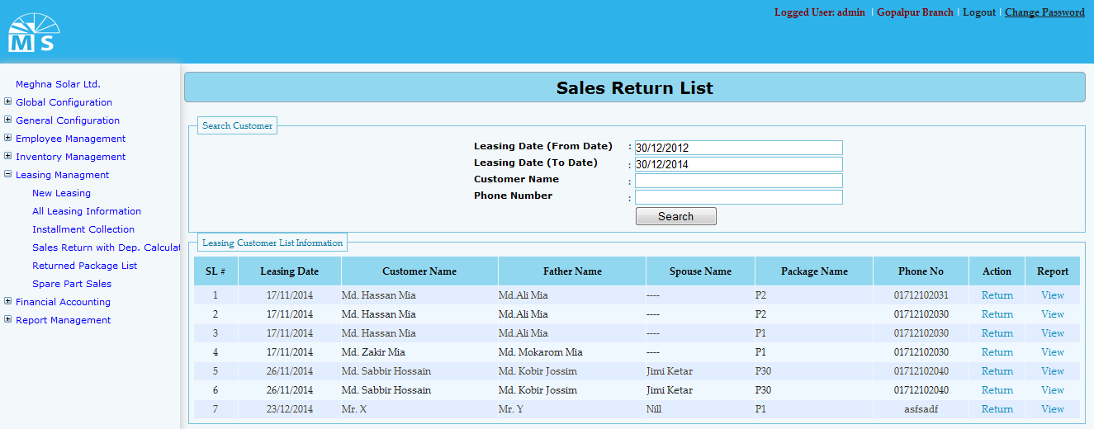

**Sales Return List**

**In Sales Return List user needs to provide date range and customer name or phone number for specific sales return information. Search information will be visible in the grid view below from where user can return sales and view report of that Sales event.**

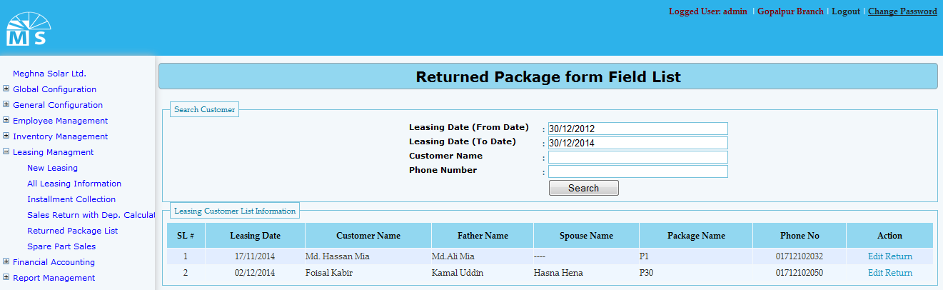

**Returned Package from field List**

**Here user needs to enter Leasing date range like before and for specific customer report need to provide Customer name and phone number. Searched information will be shown in the grid view below from which user can edit the sales return information if needed.**

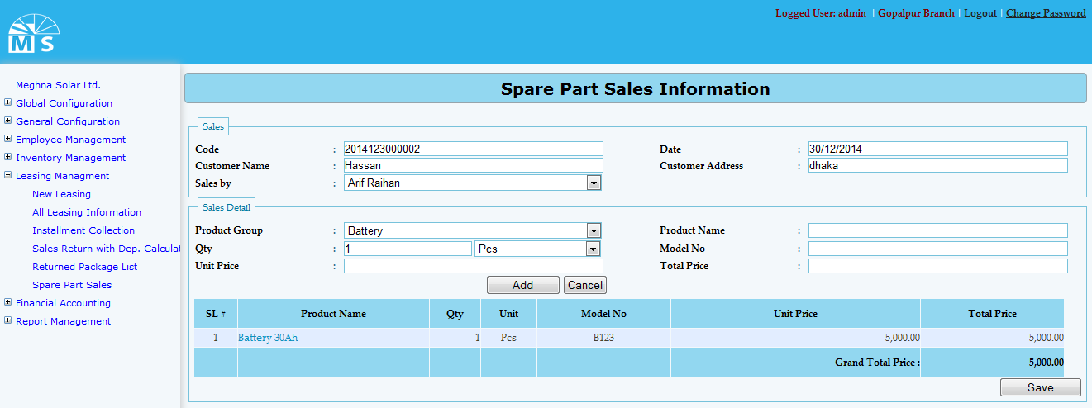

**Spare Parts Sales Information**

**Here in Spare Parts Sales form there are two sections. They are - Sales and Sales details. In Sales part user need to enter Code,Customer details and Sales by Information. Then in Sales detail part user needs to select Product group and Measurement unit from drop down list. User also need to provide Unit price, Model No and Total price to add sales details information. At last user need to click Save button for saving all the information provided above.**

**Report Management**

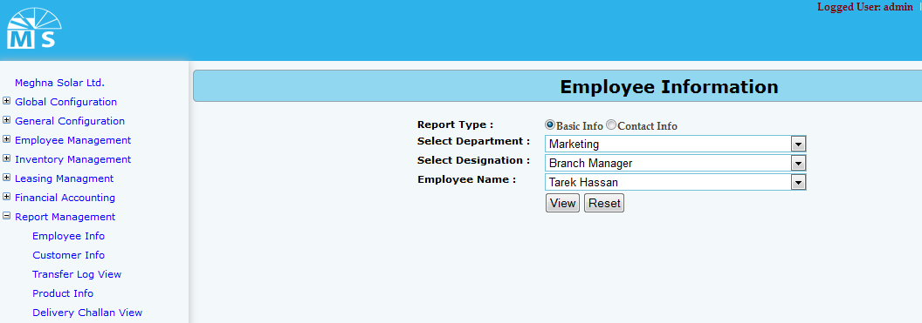

**Employee info Report (Basic info)**

**For emoployee info report there are two option. User can see Employee basic info or employee contact info. For basic info report user can directly click on view or may select department, designation and name for specific group or person’s report.**

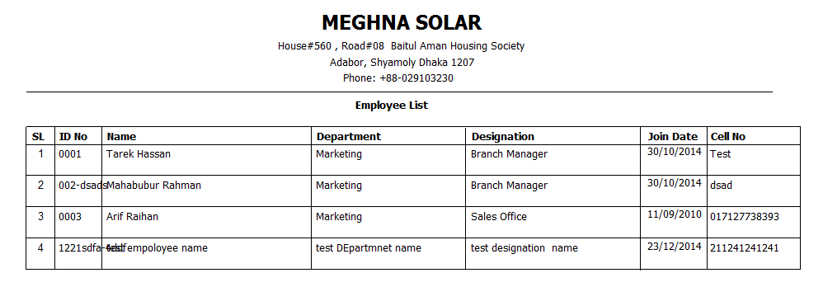

**Employee Basic Info Report**

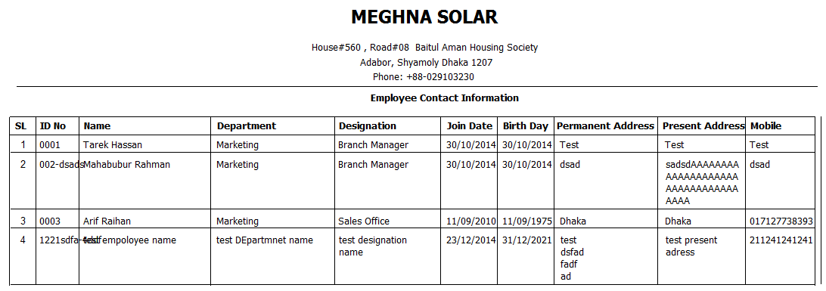

**Employee Contact Info report**

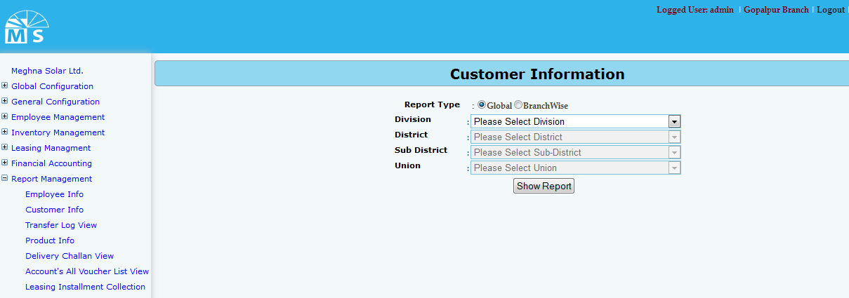

**Customer information report**

**For Customer information report there are two option. User can see Global info or Branch wise info. For Global info report user can directly click on Show report button or may select division, district, sub district and union for specific group or customer report.**

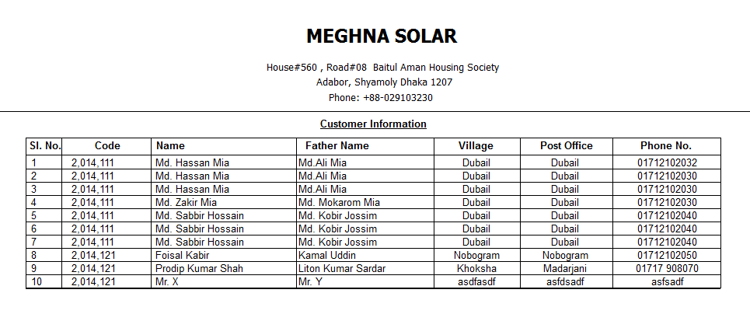

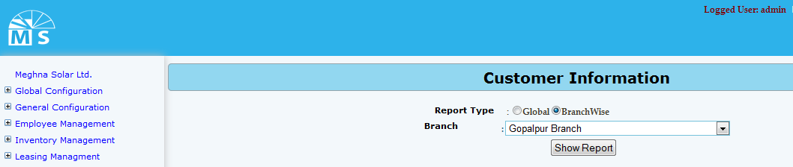**Global information report**

**Customer information report (branch wise)**

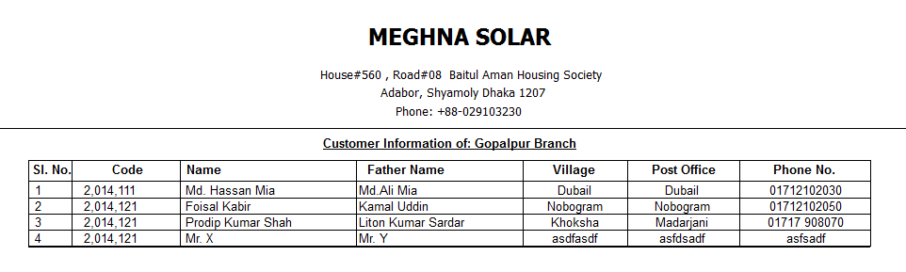

**Customer info report branch wise**

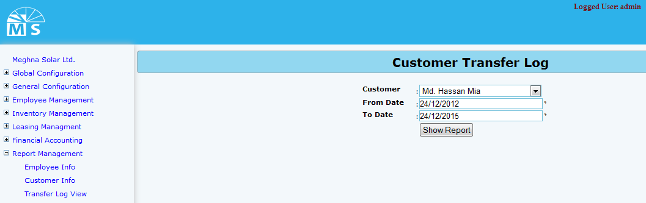

**Customer transfer log Report**

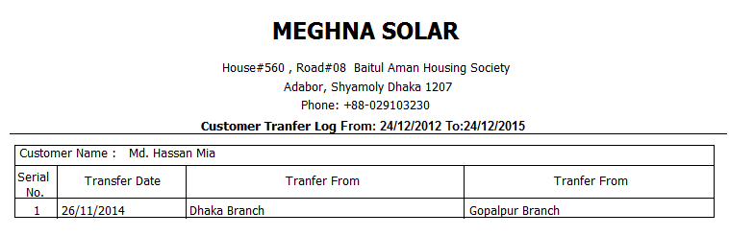

**Customer transfer log report**

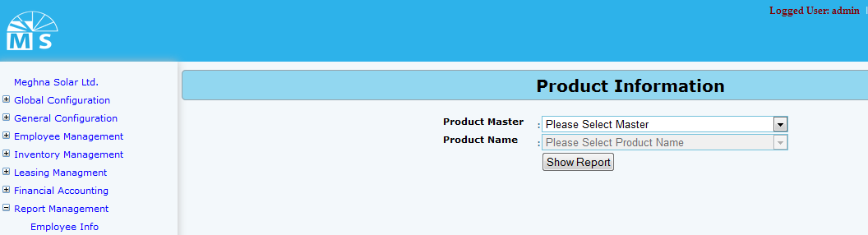

**Product information report page**

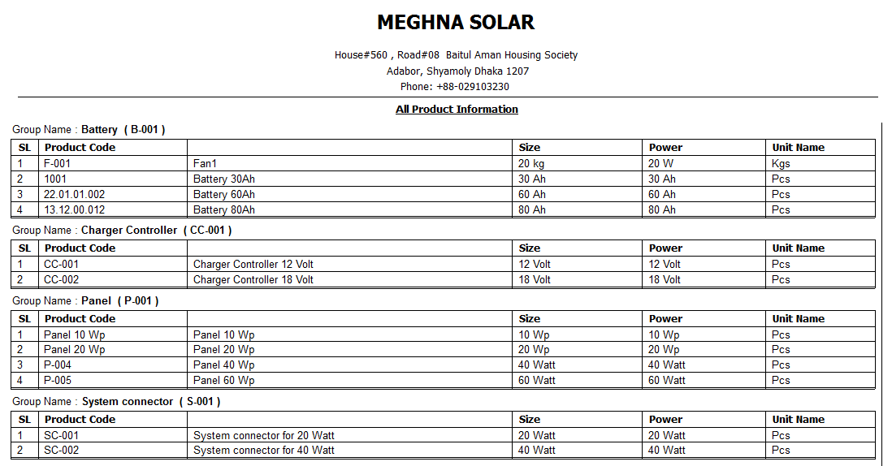

**Product information report**

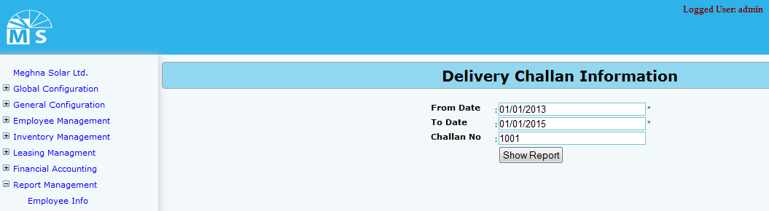

**Delivery Challan view report page**

**In Delivery Challan view report page user can view report by inserting from date and to date. Moreover for specific challan user can enter challan no and click show report button to see the report of that challan information.**

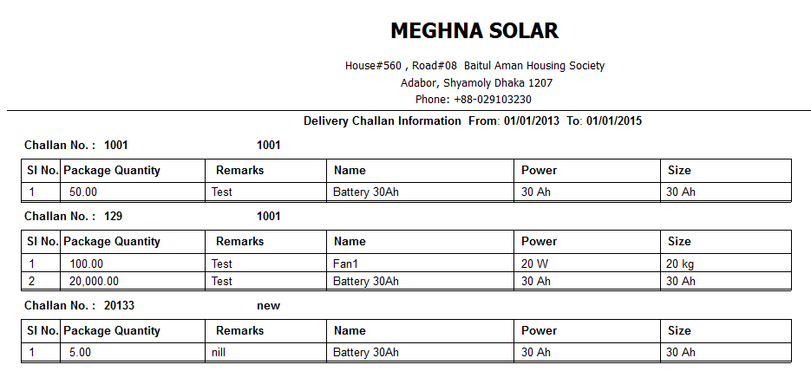

**Delivery challan view entry report**

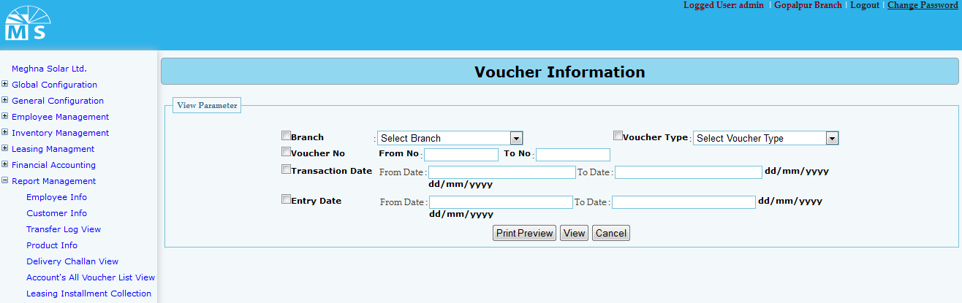

**Voucher information report page**

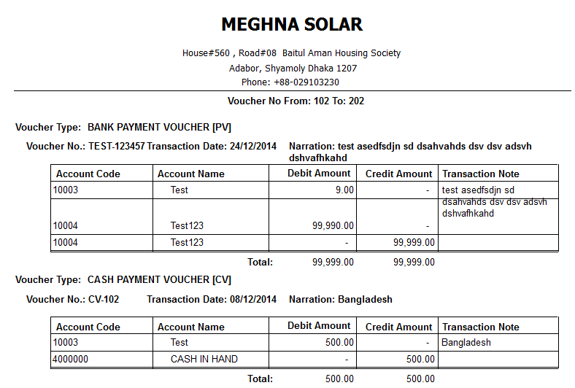

**Voucher information report**

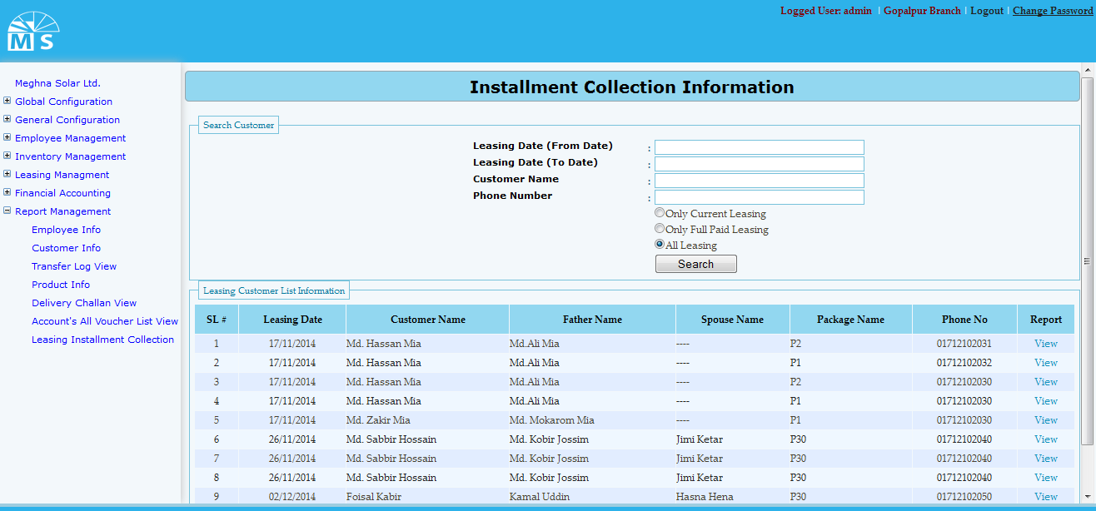

**Leasing installment collection report page**

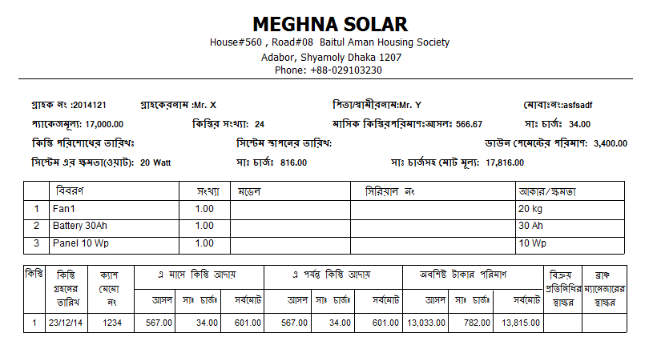

**Leasing installment collection report**